**Setup manual – FE595 Final Project**

1) Download the code and necessary files from github, this includes the files and folders shown in the screenshot below.

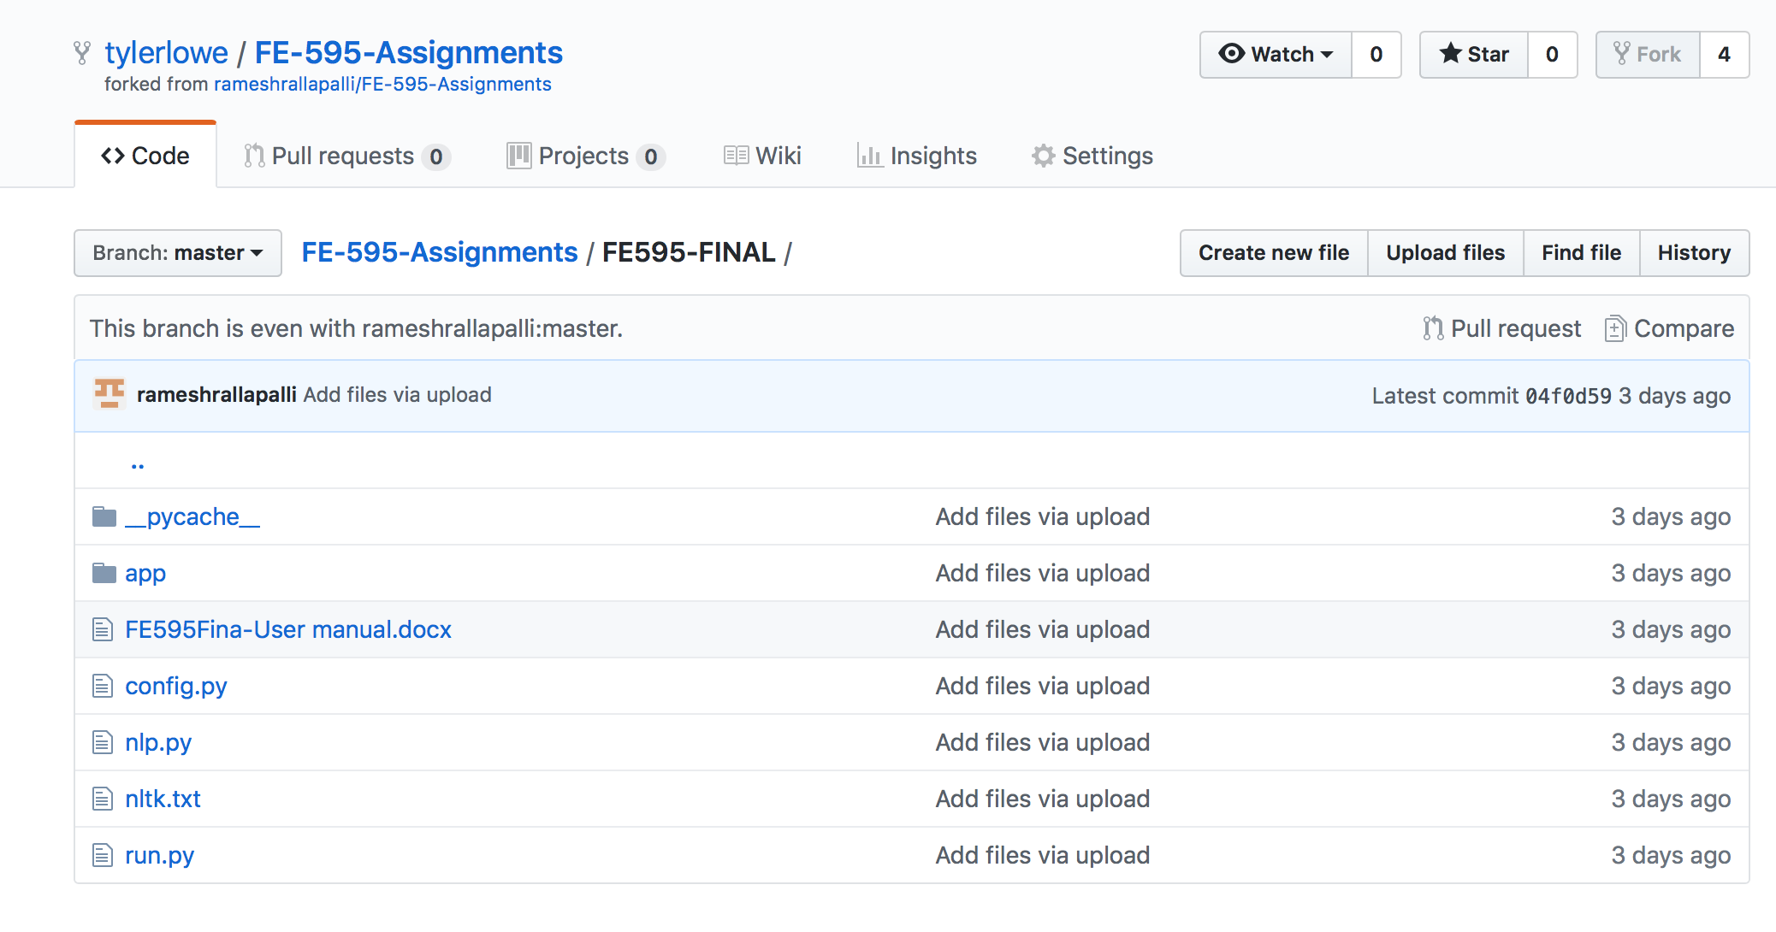

2) Open the run.py file, some packages may need to be installed before the file will run.

3) Pip install any necessary packages, these may include flask, flask_wtf, and textblob.

4) Run the run.py file, the app will then open on a browser at the URL

http://0.0.0.0:5000.

